# HOMEWORK

# Exercise: Networks, Internet and Protocols

## Trace the route to a certain IP address

1. Useing the ping command to test connectivity to an external website.

2. Add a screenshot of the result here:

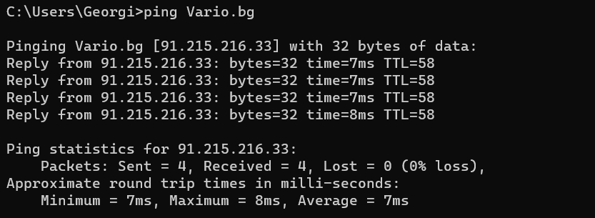

## Find the IP address behind a domain name

1. Using an online DNS lookup tool, like **DNS Checker** or **MX Toolbox** I find this IP address of a domain.

2. Add a screenshot of the result here:

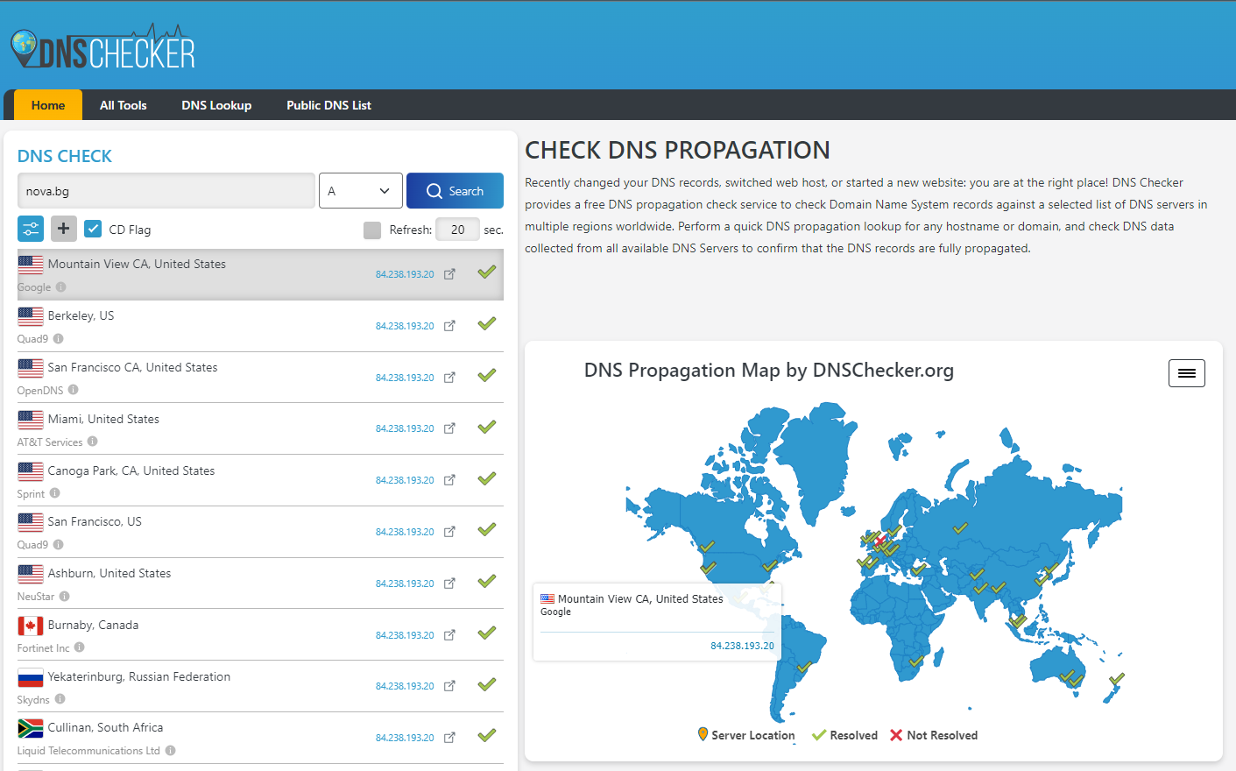

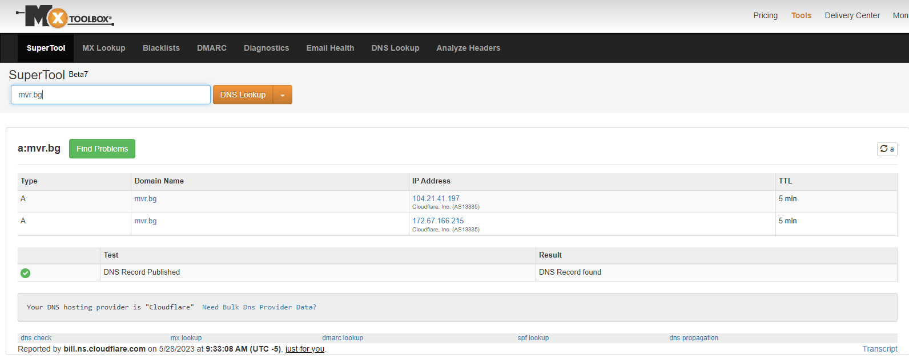

## Execute HTTP GET

1. Using [**https://restcountries.com/**](https://restcountries.com/)and DevTools on my browser. Execute a GET request for a country.

2. Add a screenshot of the result ­with DevTools open here:

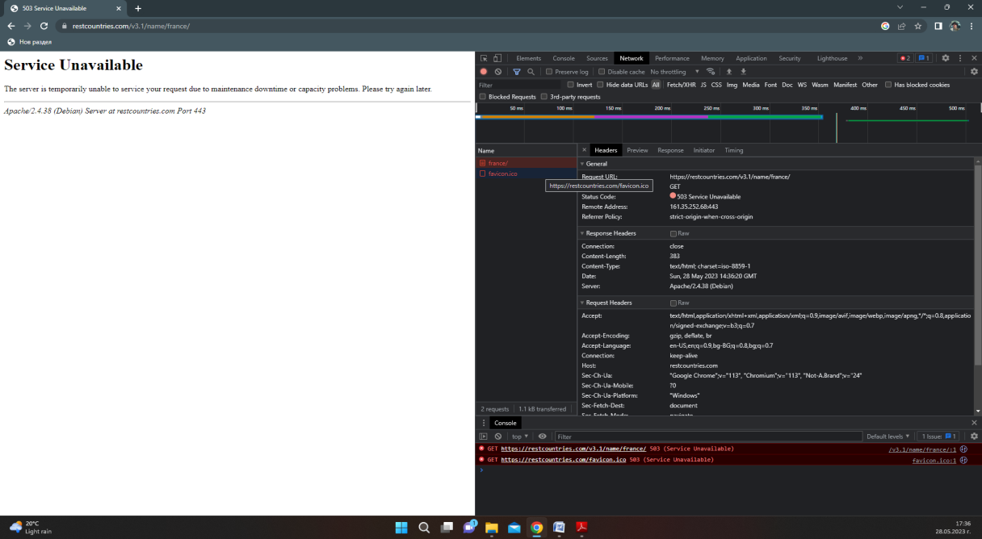

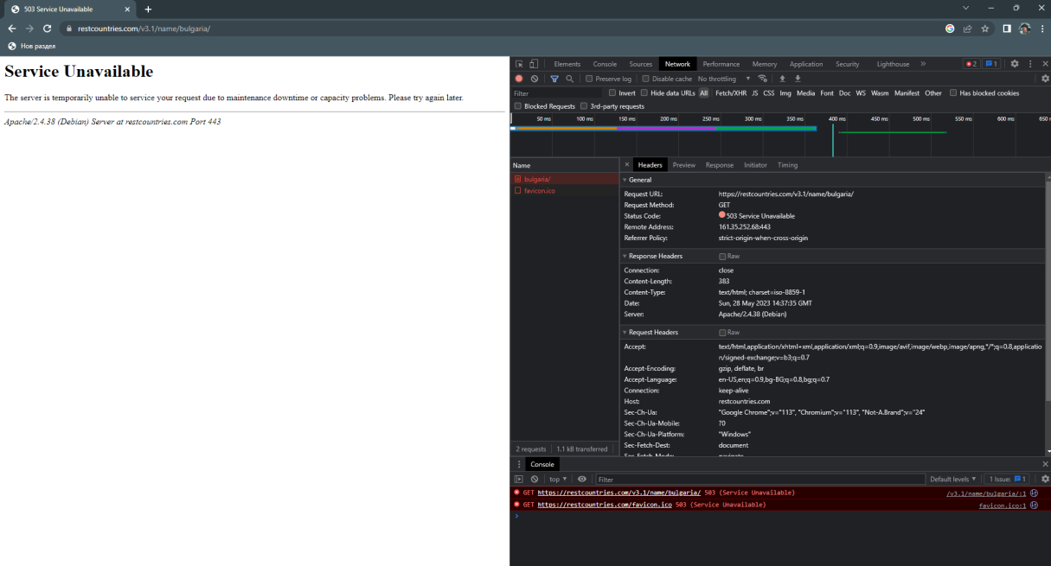

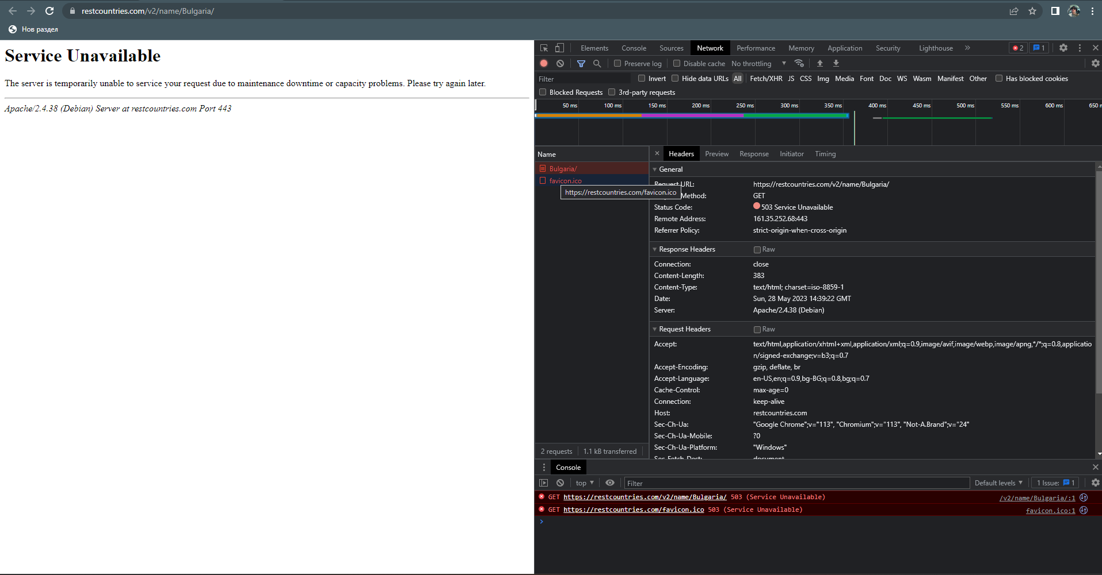

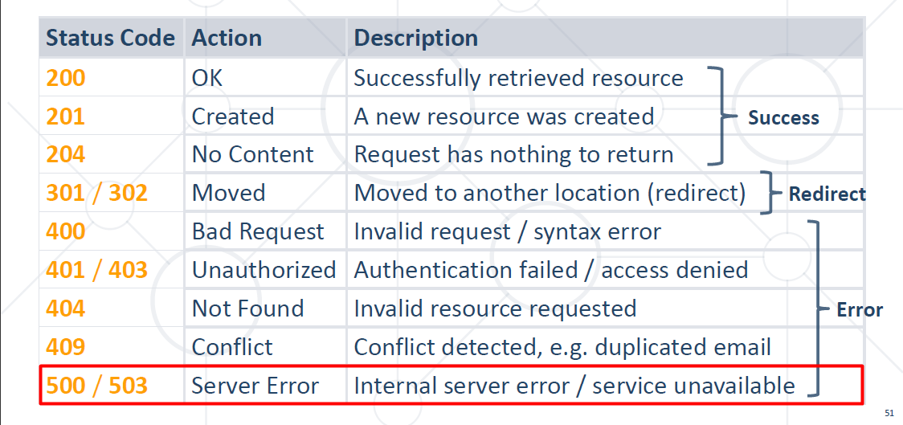

3. Apparently this site's servers are down at the moment doing the homework. I have made several attempts over a period of time on the two different versions of the site version 2 and version 3.1, but the result is the same every time. So I ran a GET request from another site, I hope my homework was done correctly despite the problem.

